GIT: 23-08-2021

* Configuring git: git config –global user.name “Name”

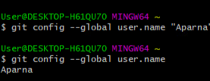

* + Adding user email

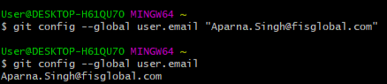

* Creating a directory and opening that directory:

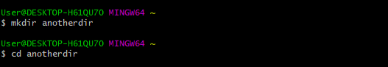

* Initializing git repository into the directory:

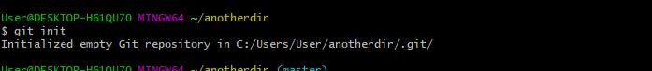

* Creating a file named “index.html” and opening in nano editor



* Writing the content into the file index.html. Then saving with ctrl +X

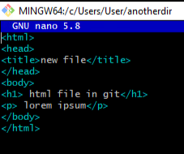

* Adding the file in staging area:

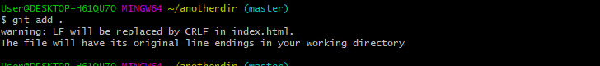

* Checking Status of files:

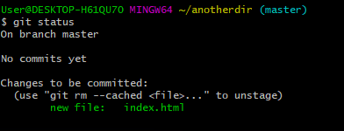

* Committing the file with the message:

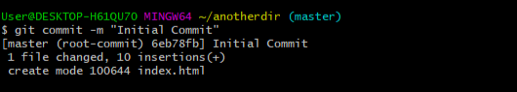

* Creating a remote connection with GitHub:

First create a repository in GitHub and copy the .git path and past it in bash



* Push the commits to remote location: git push -u origin master

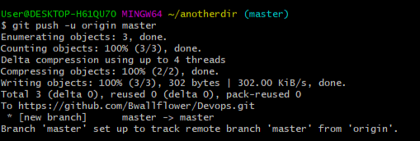

* Create a new branch:



* List all branch:

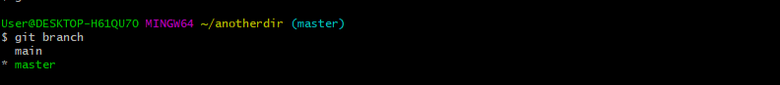

* Switch to branch:

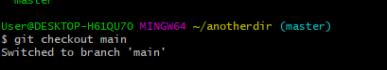

* Delete a branch:

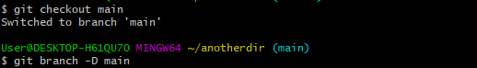

* Log of all commitments:

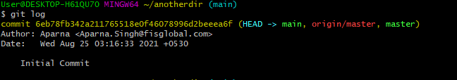

Docker:

* Installing docker in ubuntu:

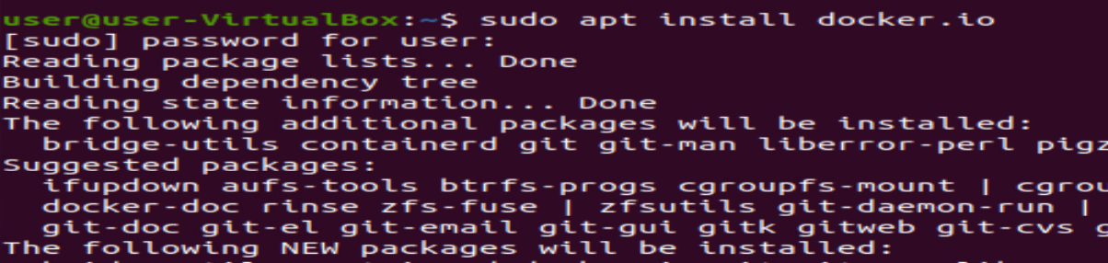

* Checking version:



* Displaying all images present in docker:

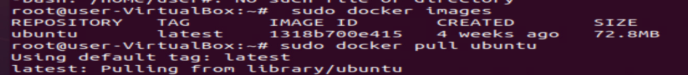

* Taking everything from docker images:

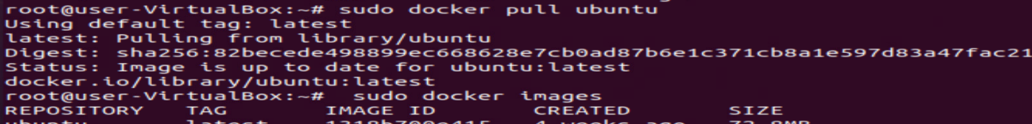

* Displaying all docker images:

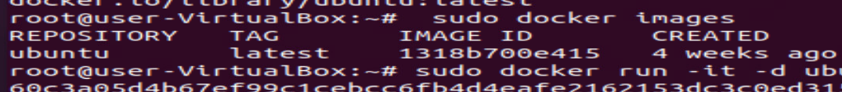

* Creating container id for docker image:

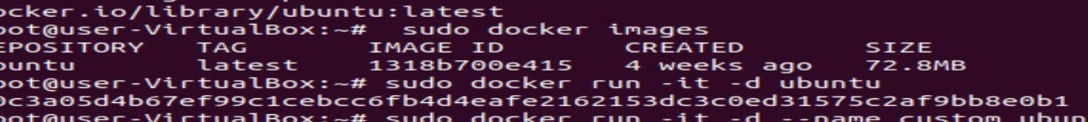

* Creating custom docker image:

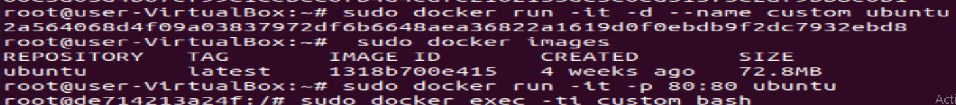

* Displaying all images:

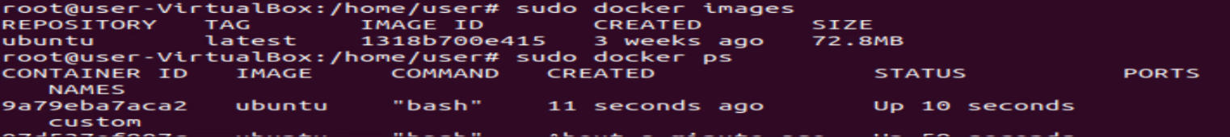

* Align container port to localhost:



* To get inside the container:



* Exit from container:

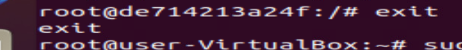

* Install nginx:

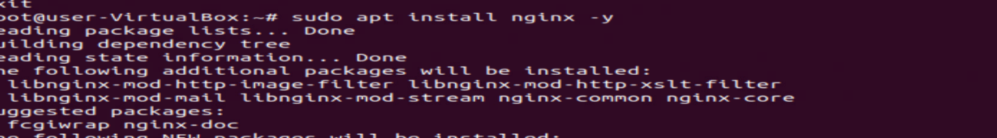

* Checking active status of nginx:

